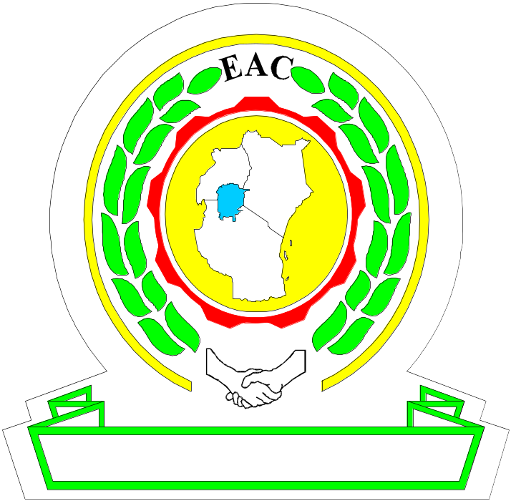

P.O. Box 1096
ARUSHA, TANZANIA

Tel: +255-27-2162100/14
Fax: +255-27-2162102/2162191
E-mail: eac@eachq.org
Web: http://www.eac.int
JUMUIYA YA AFRIKA MASHARIKI

26TH ORDINARY MEETING OF THE MONETARY AFFAIRS COMMITTEE

13TH to 17TH MARCH 2023

OPENING REMARKS BY THE CHAIR OF MAC, THE GOVERNOR OF THE BRB

Honourable Dr Patrick Njoroge, Governor of Central Bank of Kenya;
Honourable Emmanuel Tutuba, Governor of Bank of Tanzania;
Honourable Dr Michael Antingi-Ego, Deputy Governor of Bank of Uganda;
Honourable John RWANGOMBWA, Governor National Bank of Rwanda;
Honourable Johnny Ohisa Damian, Governor Bank of South Soudan;
Honourable Steven Mlote, Deputy Secretary General of EAC;

Dear Senior Officials Members of the Monetary Affairs Committee;
Distinguished Delegates, Ladies and Gentlemen. All Protocol observed;

Good Morning

Thank you to each and every one of you for being here with us today.

It is my honour and great pleasure to welcome you all to the twenty-sixth ordinary meeting of the Monetary Affairs Committee.

We thank you for your presence here in Bujumbura, and we hope you had safe trip and have enjoyed so far the good weather and the Burundian hospitality.

Honourable Governors, Ladies and Gentlemen,

Distinguished Delegates

I express my gratitude to the EAC Secretariat and to all who had worked tirelessly to organize this Meeting.
As we organise this twenty-sixth ordinary meeting of the Monetary Affairs Committee, it is important to recognise that it is the first time for some of us to take part in MAC meetings.
As Chairperson of the Committee, I would like to express a warm welcome and especially to whom is attending for the first time this important event, Honourable Emmanuel Tutuba, Governor Bank of Tanzania, and Honourable Johnny Ohisa Damian, Governor of Bank of South Soudan.

Dear Colleagues Central Bank Governors, we are all aware that the global economy is experiencing recurrent shocks making the conduct of monetary policy very challenging. The lingering effects of Covid-19 coupled with the consequences of the war between Russia-Ukraine has affected the macroeconomic performances of our respective economies.

These economic challenges harmed the attainment of monetary policy objective in general, and some macroeconomic convergence criteria. In such context, we must strengthen the cooperation and collaboration among policy makers to address the challenges that we are facing and to ensure a successful implementation of the Community’s goals for achieving our common objective.

Ladies and Gentlemen, Distinguished Guests,

Our community has made much progress with respect to the implementation of the Monetary Union Protocol, especially in terms of harmonization of regulatory framework, the adoption of the harmonized monetary and exchange policy framework, and fast tracking the macroeconomic convergence criteria,.

These achievements are the fruit of hard work made by our former chairmen who provided good leadership and dedicated their efforts to the Community interest. I take this opportunity to extend my gratitude to Dr Patrick Njoroge, Governor of Central bank of Kenya for the accomplishment reached during his Chairmanship of MAC last year. He has closely followed the administrative procedures for the establishment of EAMI and we are aware for its operationalization to be effective.

In this regard, it is important to fast track the operationalization of EAMI which is the key’s institution to foster the harmonization of monetary and exchange rate policies, as well as strengthening coordination of operational and regulatory practices. We need to progress together as one, and, i would like to reiterate to the Governors to fast track the roadmap of implementation of protocol East African Monetary Union.

During our meeting today, we will review the decisions and recommendations from the last meeting of MAC held in March 2022 and assess the progress of their implementation.

Honourable Governors, distinguished Delegates, the Bank of the Republic of Burundi reiterates its commitment to the process of integration in East African Community and will share his experience of leadership on implementation of actions planned in the roadmap of establishment of East African Monetary Union.

I appreciated the work done by different MAC Technical Committees and I invite all the EAC Partner States Central Bank to continue enhancing collaboration and cooperation in the interest of achieving the EAC integration process.

I wish this 26th MAC Meeting fruitful deliberations.

Thank you.

